
P2P COMMUNICATION
COMPUTER NETWORKS LAB PROJECT


Submitted to : Ma’am Rabia Answer
1 | Eman Fatima | 22F-3343 | BSCS 5C
2 | Ishrat | 22F-3616 | BSCS 5C
3 | Aneela Bashir | 22F-3414 | BSCS 5C
4 | Sahla | 22F-3435 | BSCS 5C

Date : 9-12-2024
Submitted by :

List of implemented peer operation(s)

- Send message
- Send file
- Upload file
- Delete file
- Download file
- Preview file
- Preview peer file
- Query
- Published
- Start server
- Connect to server
- Quite
Server.c
#include <stdio.h>
#include <stdlib.h>
#include <string.h>
#include <unistd.h>
#include <sys/socket.h>
#include <arpa/inet.h>
#include <sys/stat.h>
#include <pthread.h>
#include <dirent.h> // Include this header for directory operations
#include <arpa/inet.h>
#include <openssl/evp.h>
#include <openssl/aes.h>
#include <errno.h>
#include <fcntl.h>
#include <signal.h>
#include <openssl/evp.h>
#include <openssl/aes.h>
#include <openssl/rand.h>
#define BUFFER_SIZE 1024 // Increased buffer size
#define USERNAME "user"
#define PASSWORD "password"
#define FILE_FOLDER "server_folder"
#define KEY_SIZE 32 // AES-256
#define IV_SIZE 16 // AES block size
int client_socket = -1;
int server_socket = -1;
#define ENCRYPTION_KEY "1234567890abcdef" // 16-byte (128-bit) key

void query_files(int client_socket)
{
DIR *dir;
struct dirent *entry;

// Open the directory where files are stored
if ((dir = opendir(FILE_FOLDER)) == NULL) {
perror("Failed to open directory");
send(client_socket, "Error opening directory.\n", 25, 0);
return;
}

// Send the list of files in the directory to the client
char file_list[BUFFER_SIZE];
int first_file = 1;

while ((entry = readdir(dir)) != NULL) {
// Skip "." and ".." entries (current and parent directories)
if (strcmp(entry->d_name, ".") != 0 && strcmp(entry->d_name, "..") != 0) {
// Format the file name
snprintf(file_list, sizeof(file_list), "%s\n", entry->d_name);

// Send file name to client
send(client_socket, file_list, strlen(file_list), 0);

first_file = 0;
}
}

// If no files were found, notify the client
if (first_file) {
send(client_socket, "No files available.\n", 20, 0);
}

// Close the directory
closedir(dir);
}

int decrypt_data(const unsigned char *encrypted_data, unsigned char *decrypted_data, int encrypted_data_len, const unsigned char *key, const unsigned char *iv) {
EVP_CIPHER_CTX *ctx = EVP_CIPHER_CTX_new();
int len;
int decrypted_len = 0;

// Initialize the decryption operation (AES-256-CBC in this case)
if (1 != EVP_DecryptInit_ex(ctx, EVP_aes_256_cbc(), NULL, key, iv)) {
EVP_CIPHER_CTX_free(ctx);
return -1; // Initialization failed
}

// Decrypt the message
if (1 != EVP_DecryptUpdate(ctx, decrypted_data, &len, encrypted_data, encrypted_data_len)) {
EVP_CIPHER_CTX_free(ctx);
return -2; // Decryption update failed
}
decrypted_len = len;

// Finalize the decryption
if (1 != EVP_DecryptFinal_ex(ctx, decrypted_data + len, &len)) {
EVP_CIPHER_CTX_free(ctx);
return -3; // Finalization failed (padding issue or data corruption)
}
decrypted_len += len;

// Clean up
EVP_CIPHER_CTX_free(ctx);
return decrypted_len;
}

// Function to create the shared folder if it doesn't exist
void create_shared_folder() {
if (access(FILE_FOLDER, F_OK) == -1) {
if (mkdir(FILE_FOLDER, 0700) == -1) {
perror("Failed to create shared folder");
exit(EXIT_FAILURE);
}
printf("Shared folder '%s' created.\n", FILE_FOLDER);
}
}

void handle_file_request_peer(int client_socket, const char *filename)
{
char filepath[BUFFER_SIZE];
snprintf(filepath, sizeof(filepath), "%s/%s", FILE_FOLDER, filename);

FILE *file = fopen(filepath, "r");
if (file == NULL)
{
send(client_socket, "File not found.\n", 16, 0);
send(client_socket, "END_OF_PREVIEW", 15, 0); // Send preview end marker
return;
}

char buffer[BUFFER_SIZE];
while (fgets(buffer, sizeof(buffer), file))
{
send(client_socket, buffer, strlen(buffer), 0);
}
fclose(file);

// Send end-of-preview marker
send(client_socket, "END_OF_PREVIEW", 15, 0);
}

// Function to create a test file in the server folder
void create_test_file() {
char filepath[BUFFER_SIZE];
snprintf(filepath, sizeof(filepath), "%s/server.txt", FILE_FOLDER);

FILE *file = fopen(filepath, "w");
if (!file) {
perror("Failed to create test file");
return;
}

fprintf(file, "This is a server file created automatically by the server program.\n");
fclose(file);

printf("Test file created at %s\n", filepath);
}

// Function to handle server-side client communication
void *handle_client(void *arg)
{
int sock = *(int *)arg;
char buffer[BUFFER_SIZE];
ssize_t bytes_received;
// Step 1: Authentication
char username[BUFFER_SIZE], password[BUFFER_SIZE];
send(sock, "Enter username: ", 16, 0);
bytes_received = recv(sock, username, sizeof(username), 0);
if (bytes_received <= 0)
{
printf("Error receiving username.\n");
close(sock);
return NULL;
}
username[bytes_received] = '\0';
send(sock, "Enter password: ", 16, 0);
bytes_received = recv(sock, password, sizeof(password), 0);
if (bytes_received <= 0)
{
printf("Error receiving password.\n");
close(sock);
return NULL;
}
password[bytes_received] = '\0';
// Validate credentials
if (strcmp(username, USERNAME) != 0 || strcmp(password, PASSWORD) != 0)
{
send(sock, "Authentication failed. Closing connection.\n", 44, 0);
close(sock);
return NULL;
}
send(sock, "Authentication successful.\n", 26, 0);
printf("Client authenticated successfully.\n");
// Step 2: Communication with client
while (1) {
bytes_received = recv(sock, buffer, sizeof(buffer), 0);
if (bytes_received <= 0) {
perror("Failed to receive data");
close(sock);
return NULL;
}
buffer[bytes_received] = '\0'; // Null terminate the received string

// Tokenize the command by splitting at the first space
char *command = strtok(buffer, " "); // Get the first word (before space)
printf("Received command: '%s'\n", command);

if (command != NULL) {
if (strcmp(command, "SEND_MESSAGE:") == 0)
{
printf("Decrypted message: %s\n", buffer + strlen(command) + 1);// Decrypt and print the message part after the command
return NULL;
}
else if (strcmp(command, "SEND_FILE:") == 0)
{
// Extract the filename from the buffer after the "SEND_FILE:" command
char *filename = buffer + strlen(command) + 1; // Move past the command part to get the filename
printf("Received file command: %s\n", filename);

// Step 2: Construct the file path where to save the file
char file_path[BUFFER_SIZE];
strcpy(file_path, FILE_FOLDER);
if (file_path[strlen(file_path) - 1] != '/')
{
strcat(file_path, "/");
}
strcat(file_path, filename);

// Security check for invalid filenames
if (strchr(filename, '/') != NULL || strchr(filename, '\\') != NULL) {
fprintf(stderr, "Invalid filename.\n");
close(sock);
return NULL;
}

// Ensure file path doesn't exceed buffer size
if (strlen(file_path) >= sizeof(file_path))
{
fprintf(stderr, "Error: Path too long to create file.\n");
close(sock);
return NULL;
}

// Step 3: Open file for writing (create file if not exists)
FILE *file = fopen(file_path, "wb");
if (!file) {
perror("Failed to create file");
close(sock);
return NULL;
}

// Step 4: Receive file data in chunks and write it to the file
while ((bytes_received = recv(sock, buffer, BUFFER_SIZE, 0)) > 0) {
if (fwrite(buffer, 1, bytes_received, file) != bytes_received) {
perror("Error writing to file");
fclose(file);
close(sock);
return NULL;
}
}

// Step 5: If file is received successfully
if (bytes_received == 0)
{
printf("File '%s' received and stored successfully.\n", filename);
send(sock, "FILE_RECEIVED", strlen("FILE_RECEIVED"), 0);
}
else
{
perror("Error receiving file data");
}

fclose(file);
close(sock);
return NULL;
}

else if (strcmp(command, "UPLOAD_FILE:") == 0)
{
char *filename = buffer + strlen(command) + 1; // Move past the command part to get the filename
printf("File name: %s\n", filename);

// Print the file content that follows
printf("File content:\n");

// Now expect the file data in chunks and print it instead of writing to a file
while ((bytes_received = recv(sock, buffer, sizeof(buffer), 0)) > 0)
{
// Print the received data to the console
fwrite(buffer, 1, bytes_received, stdout); // Display the file content
}

if (bytes_received == 0)
{
printf("\nFile '%s' received successfully.\n", filename);
}
else
{
perror("Error receiving file data");
}
}
else if (strcmp(command, "DOWNLOAD_FILE:") == 0)
{
// Extract the filename from the buffer after the "SEND_FILE:" command
char *filename = buffer + strlen(command) + 1; // Move past the command part to get the filename
printf("Received file command: %s\n", filename);

// Step 2: Construct the file path where to save the file
char file_path[BUFFER_SIZE];
strcpy(file_path, FILE_FOLDER);
if (file_path[strlen(file_path) - 1] != '/')
{
strcat(file_path, "/");
}
strcat(file_path, filename);

// Ensure file path doesn't exceed buffer size
if (strlen(file_path) >= sizeof(file_path))
{
fprintf(stderr, "Error: Path too long to create file.\n");
close(sock);
return NULL;
}

// Step 3: Open file for writing (create file if not exists)
FILE *file = fopen(file_path, "wb");
if (!file) {
perror("Failed to create file");
close(sock);
return NULL;
}

// Step 4: Receive file data in chunks and write it to the file
while ((bytes_received = recv(sock, buffer, BUFFER_SIZE, 0)) > 0) {
if (fwrite(buffer, 1, bytes_received, file) != bytes_received) {
perror("Error writing to file");
fclose(file);
close(sock);
return NULL;
}
}

// Step 5: If file is received successfully
if (bytes_received == 0)
{
printf("File '%s' received and stored successfully.\n", filename);
} else
{
perror("Error receiving file data");
}

fclose(file);
return NULL;
}
if (strncmp(buffer, "PREVIEW:", 8) == 0)
{
char *filename = buffer + strlen(command) + 1; // Move past the command part to get the filename
printf("Received file command: %s\n", filename);

printf("File preview requested for: %s\n", filename); // Display a preview message on the server

// Construct the full path to the file
char file_path[BUFFER_SIZE];
strcpy(file_path, FILE_FOLDER);
strcat(file_path, "/");
strcat(file_path, filename);

// Open the file for reading
FILE *file = fopen(file_path, "rb");
if (file == NULL) {
perror("Failed to open file");
send(sock, "Failed to open file.\n", 20, 0);
return NULL;
}

// Read and send file content in chunks to the client
char buffer_preview[BUFFER_SIZE];
size_t bytes_read;
while ((bytes_read = fread(buffer_preview, 1, sizeof(buffer_preview), file)) > 0) {
// Send file content back to the peer for preview
send(sock, buffer_preview, bytes_read, 0);
}

fclose(file);

// Send the end-of-preview message
send(sock, "\nFile preview ended.\n", 21, 0);
}
else if (strncmp(command, "PUBLISH:", 8) == 0)
{
// Extract the filename from the command (skip past the "PUBLISH:" part)
char *filename = buffer + strlen(command) + 1; // Move past the command part to get the filename
printf("Received publish request for file: %s\n", filename);

// Construct the full file path
char file_path[BUFFER_SIZE];
strcpy(file_path, FILE_FOLDER); // Assuming FILE_FOLDER is defined correctly
strcat(file_path, "/");
strcat(file_path, filename); // Append the filename to the folder path

// Open the file in read mode
FILE *file = fopen(file_path, "rb");
if (!file) {
perror("Error opening file");
char *error_message = "Error opening file.\n";
send(sock, error_message, strlen(error_message), 0); // Send error message to the client
return NULL;
}

// Print the file content that follows
printf("Displaying content of file '%s':\n", filename);

// Receive and print the file content in chunks
char buffer[BUFFER_SIZE];
size_t bytes_received;

while ((bytes_received = fread(buffer, 1, sizeof(buffer), file)) > 0) {
// Print the received data to the console
fwrite(buffer, 1, bytes_received, stdout); // Display the file content
// Optionally, send the content back to the client if needed
send(sock, buffer, bytes_received, 0);
}

fclose(file); // Close the file after reading its content

printf("\nFile '%s' displayed successfully.\n", filename);
}

else if (strcmp(command, "QUERY") == 0) {
// Open the server folder
DIR *dir = opendir(FILE_FOLDER);
if (!dir) {
perror("Error opening directory");
return NULL;
}

// Prepare the list of files to send
char file_list[BUFFER_SIZE];
file_list[0] = '\0'; // Initialize the file list

struct dirent *entry;
while ((entry = readdir(dir)) != NULL)
{
if (strcmp(entry->d_name, ".") == 0 || strcmp(entry->d_name, "..") == 0)
{
continue;
}

// Add the filename to the list
if (strlen(file_list) + strlen(entry->d_name) + 2 < sizeof(file_list))
{
strcat(file_list, entry->d_name);
strcat(file_list, "\n"); // Newline separates filenames
}
}

closedir(dir);

// If no files were found, send a message indicating so
if (strlen(file_list) == 0)
{
strcpy(file_list, "No files available in the server folder.\n");
}

// Send the list of files to the client
send(sock, file_list, strlen(file_list), 0);
}

else
{
//printf("Unknown command received: %s\n", buffer);
//send(sock, "Unknown command.\n", 18, 0);
}
}
}

close(sock);
}

// Function to start the server
void start_server(int port)
{
struct sockaddr_in server_addr, client_addr;
socklen_t client_len = sizeof(client_addr);

server_socket = socket(AF_INET, SOCK_STREAM, 0);
if (server_socket == -1) {
perror("Failed to create server socket");
exit(EXIT_FAILURE);
}

server_addr.sin_family = AF_INET;
server_addr.sin_addr.s_addr = INADDR_ANY;
server_addr.sin_port = htons(port);

if (bind(server_socket, (struct sockaddr *)&server_addr, sizeof(server_addr)) == -1) {
perror("Failed to bind server socket");
exit(EXIT_FAILURE);
}

if (listen(server_socket, 5) == -1) {
perror("Failed to listen on server socket");
exit(EXIT_FAILURE);
}

printf("Server started on port %d. Waiting for connections...\n", port);

while (1) {
int client_socket = accept(server_socket, (struct sockaddr *)&client_addr, &client_len);
if (client_socket == -1) {
perror("Failed to accept client connection");
continue;
}

printf("Client connected.\n");

pthread_t server_thread;
if (pthread_create(&server_thread, NULL, handle_client, &client_socket) != 0) {
perror("Failed to create thread");
close(client_socket);
continue;
}

pthread_detach(server_thread);
}
}

void signal_handler(int sig) {
printf("\nServer shutting down...\n");

// Notify the client that the server is shutting down
if (client_socket != -1) {
const char *shutdown_message = "Server is shutting down...\n";
send(client_socket, shutdown_message, strlen(shutdown_message), 0);
close(client_socket); // Close the client socket
}

if (server_socket != -1) {
close(server_socket); // Close the server socket
}

exit(0);
}

int main() {
int port;
printf("Enter port to start server on: ");
scanf("%d", &port);
getchar(); // Consume newline

create_shared_folder();
create_test_file();

signal(SIGINT, signal_handler); // Handle Ctrl+C to clean up resources

start_server(port);

return 0;
}
Client.c :
#include <stdio.h>
#include <stdlib.h>
#include <string.h>
#include <unistd.h>
#include <sys/socket.h>
#include <arpa/inet.h>
#include <sys/stat.h>
#include <pthread.h>
#include <dirent.h> // Include this header for directory operations
#include <arpa/inet.h>
#include <openssl/evp.h>
#include <openssl/aes.h>
#include <errno.h>
#include <fcntl.h>
#include <signal.h>
#define BUFFER_SIZE 1024
#define FILE_FOLDER "p2p-files"
#define USERNAME "user"
#define PASSWORD "password"
#define ENCRYPTION_KEY "0123456789abcdef" // AES encryption key (16 bytes)
// Global variables
extern int peer_socket; // Connection to the peer
extern int server_socket; // Connection to the server
int server_socket = -1;
int client_socket = -1;
int peer_socket = -1;

int encrypt_data(const unsigned char *input, unsigned char *output, int length) {
EVP_CIPHER_CTX *ctx;
int len;
int ciphertext_len;

// Initialize the context
if (!(ctx = EVP_CIPHER_CTX_new())) {
perror("EVP_CIPHER_CTX_new failed");
return -1;
}

// Initialize the encryption operation with AES-128-ECB
if (1 != EVP_EncryptInit_ex(ctx, EVP_aes_128_ecb(), NULL, (unsigned char *)ENCRYPTION_KEY, NULL)) {
perror("EVP_EncryptInit_ex failed");
EVP_CIPHER_CTX_free(ctx);
return -1;
}

// Encrypt the input data
if (1 != EVP_EncryptUpdate(ctx, output, &len, input, length)) {
perror("EVP_EncryptUpdate failed");
EVP_CIPHER_CTX_free(ctx);
return -1;
}
ciphertext_len = len;

// Finalize encryption
if (1 != EVP_EncryptFinal_ex(ctx, output + len, &len)) {
perror("EVP_EncryptFinal_ex failed");
EVP_CIPHER_CTX_free(ctx);
return -1;
}
ciphertext_len += len;

// Clean up
EVP_CIPHER_CTX_free(ctx);

// Debugging: Print encrypted data in hex
printf("Encrypted data (hex): ");
for (int i = 0; i < ciphertext_len; i++) {
printf("%02x ", output[i]);
}
printf("\n");

return ciphertext_len; // Return the length of the encrypted data
}

int authenticate_client(int client_socket) {
char buffer[BUFFER_SIZE];

// Send authentication prompt to client
send(client_socket, "Enter username: ", strlen("Enter username: "), 0);
recv(client_socket, buffer, sizeof(buffer), 0); // Receive username from client
buffer[strcspn(buffer, "\n")] = 0; // Remove newline character

if (strcmp(buffer, USERNAME) != 0) {
send(client_socket, "Invalid username.\n", strlen("Invalid username.\n"), 0);
return 0; // Authentication failed
}

// Send password prompt to client
send(client_socket, "Enter password: ", strlen("Enter password: "), 0);
recv(client_socket, buffer, sizeof(buffer), 0); // Receive password from client
buffer[strcspn(buffer, "\n")] = 0; // Remove newline character

if (strcmp(buffer,PASSWORD ) != 0) {
send(client_socket, "Invalid password.\n", strlen("Invalid password.\n"), 0);
return 0; // Authentication failed
}

send(client_socket, "Authentication successful.\n", strlen("Authentication successful.\n"), 0);
return 1; // Authentication successful
}
// Function to handle server-side client communication
void *handle_client(void *arg) {
int sock = *(int *)arg;
char buffer[BUFFER_SIZE];
ssize_t bytes_received;

// Authentication
if (!authenticate_client(sock)) {
printf("Authentication failed. Closing connection.\n");
close(sock);
return NULL;
}

printf("Authentication successful. Proceeding with communication.\n");

// Send a welcome message to the client
send(sock, "Welcome to the server!\n", strlen("Welcome to the server!\n"), 0);

while (1) {
// Step 1: Receive client message (e.g., "query" or filename for file upload)
bytes_received = recv(sock, buffer, sizeof(buffer), 0);
if (bytes_received <= 0) {
// Connection closed or error
printf("Connection closed by peer.\n");
break;
}

buffer[bytes_received] = '\0'; // Null-terminate the received string

// Handle "query" command to list files in the shared folder
if (strcmp(buffer, "query") == 0)
{
char file_list[BUFFER_SIZE] = "";
struct dirent *entry;
DIR *dir = opendir(FILE_FOLDER);

if (dir == NULL) {
perror("Failed to open directory");
break;
}

// Iterate through the files in the folder
while ((entry = readdir(dir)) != NULL)
{
// Skip current directory and parent directory entries ('.' and '..')
if (strcmp(entry->d_name, ".") != 0 && strcmp(entry->d_name, "..") != 0) {
strcat(file_list, entry->d_name);
strcat(file_list, "\n");
}
}

closedir(dir);
// Send the list of files to the client
if (strlen(file_list) == 0)
{
strcpy(file_list, "No files found.\n");
}
send(sock, file_list, strlen(file_list), 0);
}
else
{
// Handle other client messages
printf("Received from client: %s\n", buffer);

// Handle file upload logic here
char file_path[BUFFER_SIZE];
strcpy(file_path, FILE_FOLDER);

// Ensure there is a '/' separating the directory and the filename
if (file_path[strlen(file_path) - 1] != '/') {
strcat(file_path, "/");
}

// Concatenate the received filename to the path
strcat(file_path, buffer);

// Ensure the file path doesn't exceed buffer size
if (strlen(file_path) >= sizeof(file_path)) {
fprintf(stderr, "Error: Path too long to create file.\n");
break;
}

// Open the file for writing (create it if it doesn't exist)
FILE *file = fopen(file_path, "wb");
if (!file) {
perror("Failed to create file");
break;
}

// Step 2: Receive and write file data
while ((bytes_received = recv(sock, buffer, BUFFER_SIZE, 0)) > 0)
{
if (fwrite(buffer, 1, bytes_received, file) != bytes_received)
{
perror("Error writing to file");
fclose(file);
break;
}
}

// If the entire file is received successfully
if (bytes_received == 0) {
printf("File '%s' received and stored successfully.\n", buffer);
} else {
perror("Error receiving file data");
}

fclose(file);
}
}

close(sock);
return NULL;
}

// Server code that listens for connections and starts a thread for each client
void start_server(int port) {
struct sockaddr_in server_addr, client_addr;
socklen_t client_len = sizeof(client_addr);

// Create server socket
server_socket = socket(AF_INET, SOCK_STREAM, 0);
if (server_socket == -1) {
perror("Failed to create server socket");
exit(EXIT_FAILURE);
}

server_addr.sin_family = AF_INET;
server_addr.sin_addr.s_addr = INADDR_ANY;
server_addr.sin_port = htons(port);

// Bind socket to the address and port
if (bind(server_socket, (struct sockaddr *)&server_addr, sizeof(server_addr)) == -1) {
perror("Failed to bind server socket");
exit(EXIT_FAILURE);
}

// Start listening for incoming connections
if (listen(server_socket, 5) == -1) {
perror("Failed to listen on server socket");
exit(EXIT_FAILURE);
}

printf("Server started on port %d. Waiting for connections...\n", port);

while (1) {
// Accept client connection
client_socket = accept(server_socket, (struct sockaddr *)&client_addr, &client_len);
if (client_socket == -1) {
perror("Failed to accept client connection");
continue;
}

printf("Client connected.\n");

// Create a thread to handle the client
pthread_t server_thread;
pthread_create(&server_thread, NULL, handle_client, &client_socket);
pthread_detach(server_thread); // Detach the thread so it can be cleaned up automatically
}
}

// Wrapper function to start the server in a separate thread
void *server_thread_function(void *arg) {
int port = *(int *)arg;
start_server(port);
return NULL;
}

void authenticate_with_server() {
char buffer[BUFFER_SIZE];
char username[BUFFER_SIZE]; // Declare a local variable for username
char password[BUFFER_SIZE]; // Declare a local variable for password

// Receive username prompt from server
recv(peer_socket, buffer, sizeof(buffer), 0);
printf("%s", buffer);

// Send username to the server
fgets(username, sizeof(username), stdin);
username[strcspn(username, "\n")] = '\0'; // Remove newline character
send(peer_socket, username, strlen(username), 0);

// Receive password prompt from server
recv(peer_socket, buffer, sizeof(buffer), 0);
printf("%s", buffer);

// Send password to the server
fgets(password, sizeof(password), stdin);
password[strcspn(password, "\n")] = '\0'; // Remove newline character
send(peer_socket, password, strlen(password), 0);

// Receive authentication result from server
recv(peer_socket, buffer, sizeof(buffer), 0);
printf("%s", buffer);

// Handle authentication success or failure
if (strstr(buffer, "Authentication successful") == NULL) {
printf("Authentication failed. Exiting...\n");
close(peer_socket);
exit(EXIT_FAILURE); // Exit the program if authentication fails
}

printf("Authentication successful. You can now communicate with the server.\n");
}

void connect_to_peer(const char *ip, int port) {
struct sockaddr_in peer_addr;

// Create socket
peer_socket = socket(AF_INET, SOCK_STREAM, 0);
if (peer_socket == -1) {
perror("Failed to create peer socket");
exit(EXIT_FAILURE);
}

peer_addr.sin_family = AF_INET;
peer_addr.sin_port = htons(port);

// Convert IP address from text to binary
if (inet_pton(AF_INET, ip, &peer_addr.sin_addr) <= 0) {
perror("Invalid IP address format");
exit(EXIT_FAILURE);
}

// Attempt to connect to the peer
if (connect(peer_socket, (struct sockaddr *)&peer_addr, sizeof(peer_addr)) == -1) {
perror("Failed to connect to peer");
exit(EXIT_FAILURE); // Exit if connection fails
}

printf("Connected to peer %s:%d\n", ip, port);

// Authenticate after connecting
authenticate_with_server();
}
// Function to create a folder if it doesn't exist
void create_shared_folder() {
if (access(FILE_FOLDER, F_OK) == -1) {
// Directory doesn't exist, create it
if (mkdir(FILE_FOLDER, 0700) == -1) {
perror("Failed to create shared folder");
exit(EXIT_FAILURE);
}
printf("Shared folder '%s' created.\n", FILE_FOLDER);
}
}

// Function to delete a file in the shared folder
void delete_file()
{
char filename[BUFFER_SIZE];
printf("Enter filename to delete: ");
fgets(filename, sizeof(filename), stdin);
filename[strcspn(filename, "\n")] = '\0';

if (strlen(filename) + strlen(FILE_FOLDER) + 1 >= BUFFER_SIZE) {
printf("Filename too long.\n");
return;
}

char filepath[BUFFER_SIZE];
int written = snprintf(filepath, sizeof(filepath), "%s/%s", FILE_FOLDER, filename);

if (written < 0 || written >= sizeof(filepath)) {
printf("Failed to construct filepath.\n");
return;
}

if (remove(filepath) == 0) {
printf("File deleted: %s\n", filepath);
} else {
perror("Error deleting file");
}
}

// Function to create a test file in the shared folder
void create_test_file() {
char filepath[BUFFER_SIZE];
snprintf(filepath, sizeof(filepath), "%s/file.txt", FILE_FOLDER);

// Create or overwrite the file
FILE *file = fopen(filepath, "w");
if (!file) {
perror("Failed to create test file");
return;
}

// Write some content to the file
fprintf(file, "This is a test file created automatically by the client program.\n");
fclose(file);

printf("Test file created at %s\n", filepath);
}
// Function to send message to server

// Function to send message to peer
void send_message_to_peer() {
if (peer_socket == -1) {
printf("No peer connected. Use option 2 to connect to a peer first.\n");
return;
}

char message[BUFFER_SIZE];
printf("Enter message: ");
fgets(message, sizeof(message), stdin);
message[strcspn(message, "\n")] = '\0'; // Remove newline character

unsigned char encrypted_message[BUFFER_SIZE];
int message_length = strlen(message);

// Encrypt the message
int encrypted_length = encrypt_data((unsigned char *)message, encrypted_message, message_length);

// Send the command and the encrypted message
char formatted_message[BUFFER_SIZE];
// Instead of snprintf, directly concatenate the command and message
strcpy(formatted_message, "SEND_MESSAGE: ");
strcat(formatted_message, message); // Append message to the command

send(peer_socket, formatted_message, strlen(formatted_message), 0); // Send the command first
printf("Encrypted message sent.\n");
}

// Function to send file to peer
void send_file_to_peer()
{
if (peer_socket == -1)
{
printf("No peer connected. Use option 2 to connect to a peer first.\n");
return;
}

char filename[BUFFER_SIZE];
printf("Enter filename to send: ");
fgets(filename, sizeof(filename), stdin);
filename[strcspn(filename, "\n")] = '\0'; // Remove newline character

// Construct the filepath
char filepath[BUFFER_SIZE];
strcpy(filepath, FILE_FOLDER); // Copy the folder path
strcat(filepath, "/"); // Add the directory separator
strcat(filepath, filename); // Append the filename

FILE *file = fopen(filepath, "rb");
if (!file)
{
printf("File not found: %s\n", filepath);
return;
}

// Send the command and the filename first
char formatted_message[BUFFER_SIZE];
strcpy(formatted_message, "SEND_FILE: "); // Copy command into the message
strcat(formatted_message, filename); // Append the filename

// Ensure null-termination of the message
formatted_message[BUFFER_SIZE - 1] = '\0';

if (send(peer_socket, formatted_message, strlen(formatted_message), 0) == -1) {
perror("Error sending command to peer");
fclose(file);
return;
}

// Now send the file content in chunks
char buffer[BUFFER_SIZE];
size_t bytes_read;
while ((bytes_read = fread(buffer, 1, BUFFER_SIZE, file)) > 0) {
if (send(peer_socket, buffer, bytes_read, 0) == -1) {
perror("Error sending file data");
fclose(file);
return;
}
}

fclose(file);
printf("File '%s' sent successfully.\n", filename);
}

void upload_file(const char *file_path)
{
if (peer_socket == -1) {
printf("No peer connected. Please connect to a peer first.\n");
return;
}

FILE *file = fopen(file_path, "rb");
if (file == NULL) {
perror("Failed to open file");
return;
}

// Extract the filename from the full file path
char file_name[BUFFER_SIZE];
strcpy(file_name, file_path);
char *file_name_only = strrchr(file_name, '/'); // Get only the file name
if (file_name_only) {
file_name_only++; // Move past the '/' to get the file name
} else {
file_name_only = file_name; // In case there is no directory in the path
}

// Send the "UPLOAD_FILE" command with the file name
char formatted_message[BUFFER_SIZE];
strcpy(formatted_message, "UPLOAD_FILE: "); // Copy command into the message
strcat(formatted_message, file_name_only); // Append the filename

if (send(peer_socket, formatted_message, strlen(formatted_message), 0) == -1) {
perror("Error sending command to peer");
fclose(file);
return;
}

// Send the file content in chunks
char buffer[BUFFER_SIZE];
size_t bytes_read;
while ((bytes_read = fread(buffer, 1, sizeof(buffer), file)) > 0) {
if (send(peer_socket, buffer, bytes_read, 0) == -1) {
perror("Error sending file data");
fclose(file);
return;
}
}

printf("File uploaded successfully.\n");
fclose(file);
}

// Function to publish files
void publish_files() {
if (peer_socket == -1) {
printf("No peer connected. Please connect to a peer first.\n");
return;
}

// Prepare the list of files to publish
int num_files;
printf("Enter the number of files to publish: ");
scanf("%d", &num_files);
getchar(); // Consume newline

for (int i = 0; i < num_files; i++) {
char filename[BUFFER_SIZE];
printf("Enter filename to publish: ");
fgets(filename, sizeof(filename), stdin);
filename[strcspn(filename, "\n")] = '\0'; // Remove newline character

// Construct the full path to the file manually
char file_path[BUFFER_SIZE];
strcpy(file_path, FILE_FOLDER); // Copy folder path to file_path
strcat(file_path, "/"); // Append directory separator
strcat(file_path, filename); // Append filename to the path

// Check if the file exists and if it's within the correct directory
FILE *file = fopen(file_path, "r");
if (!file) {
printf("Error: Could not open file %s in folder %s\n", filename, FILE_FOLDER);
continue; // Skip to the next file if the current one can't be opened
}

// Verify the file is within the correct folder
if (strncmp(file_path, FILE_FOLDER, strlen(FILE_FOLDER)) != 0) {
printf("Error: The file %s is not located in the correct directory: %s\n", filename, FILE_FOLDER);
fclose(file);
continue; // Skip to the next file
}

// Send the "PUBLISH" command with the filename to the peer
char command[BUFFER_SIZE];
strcpy(command, "PUBLISH: "); // Command to indicate publishing
strcat(command, filename); // Append filename to the command
send(peer_socket, command, strlen(command), 0); // Send the "PUBLISH" command

// Display file content on the client side
printf("Displaying contents of file '%s':\n", filename);
char file_content[BUFFER_SIZE];
size_t bytes_read;
while ((bytes_read = fread(file_content, 1, sizeof(file_content) - 1, file)) > 0) {
file_content[bytes_read] = '\0'; // Null-terminate the buffer
printf("%s", file_content); // Print file content to the client console
send(peer_socket, file_content, bytes_read, 0); // Send content to the peer
}

fclose(file);
printf("\nFile '%s' published successfully.\n", filename);
}
}

// Function to query files from the server (peer)
void query_files() {
if (peer_socket == -1) {
printf("No peer connected. Please connect to a peer first.\n");
return;
}

// Send a "QUERY" command to the connected peer to request the list of files
const char *query_command = "QUERY";
if (send(peer_socket, query_command, strlen(query_command), 0) == -1) {
perror("Error sending QUERY command to peer");
return;
}

// Receive the list of files from the server (peer)
char buffer[BUFFER_SIZE];
ssize_t bytes_received = recv(peer_socket, buffer, sizeof(buffer), 0);
if (bytes_received <= 0) {
printf("Failed to receive file list or peer closed the connection.\n");
return;
}

// Null-terminate the received data and display the file list
buffer[bytes_received] = '\0';
printf("Files available from peer:\n%s\n", buffer);
}

void download_file(const char *file_path)
{
if (peer_socket == -1) {
printf("No peer connected. Please connect to a peer first.\n");
return;
}

FILE *file = fopen(file_path, "rb");
if (file == NULL) {
perror("Failed to open file");
return;
}

// Extract the filename from the full file path
char file_name[BUFFER_SIZE];
strcpy(file_name, file_path);
char *file_name_only = strrchr(file_name, '/'); // Get only the file name
if (file_name_only) {
file_name_only++; // Move past the '/' to get the file name
} else {
file_name_only = file_name; // In case there is no directory in the path
}

// Send the "UPLOAD_FILE" command with the file name
char formatted_message[BUFFER_SIZE];
strcpy(formatted_message, "DOWNLOAD_FILE: "); // Copy command into the message
strcat(formatted_message, file_name_only); // Append the filename

if (send(peer_socket, formatted_message, strlen(formatted_message), 0) == -1) {
perror("Error sending command to peer");
fclose(file);
return;
}

// Send the file content in chunks
char buffer[BUFFER_SIZE];
size_t bytes_read;
while ((bytes_read = fread(buffer, 1, sizeof(buffer), file)) > 0) {
if (send(peer_socket, buffer, bytes_read, 0) == -1) {
perror("Error sending file data");
fclose(file);
return;
}
}

printf("File download successfully.\n");
fclose(file);
}

void preview_file_peer(const char *filename)
{
if (peer_socket == -1) {
printf("No peer connected. Please connect to a peer first.\n");
return;
}

// Send the "PREVIEW" command with the filename to the server
char request[BUFFER_SIZE];
strcpy(request, "PREVIEW: ");
strcat(request, filename); // Append filename to the command
send(peer_socket, request, strlen(request), 0); // Send the request to the server

// Set up the file descriptor set for select()
fd_set read_fds;
FD_ZERO(&read_fds);
FD_SET(peer_socket, &read_fds);

// Wait for the socket to be ready for reading, with a timeout of 1 second
struct timeval timeout;
timeout.tv_sec = 1;
timeout.tv_usec = 0;

char buffer[BUFFER_SIZE];
int bytes_received;

printf("File preview from peer:\n");

while (1) {
int select_result = select(peer_socket + 1, &read_fds, NULL, NULL, &timeout);

if (select_result == -1) {
perror("Select failed");
break;
}
else if (select_result == 0)
{
printf("\nFile preview ended.\n");
break;
} else {
// Data is available, read it
bytes_received = recv(peer_socket, buffer, sizeof(buffer) - 1, 0);
if (bytes_received > 0) {
buffer[bytes_received] = '\0'; // Null-terminate the received data
printf("%s", buffer); // Print the received data (file content) to the client terminal
} else {
printf("\nFile preview ended.\n");
break;
}
}
}
}

void signal_handler(int sig) {
printf("\nServer shutting down...\n");

// Notify the client that the server is shutting down
if (client_socket != -1) {
const char *shutdown_message = "Server is shutting down...\n";
send(client_socket, shutdown_message, strlen(shutdown_message), 0);
close(client_socket); // Close the client socket
}

if (server_socket != -1) {
close(server_socket); // Close the server socket
}

exit(0);
}
void preview_file(const char *filename)
{
char filepath[BUFFER_SIZE];
snprintf(filepath, sizeof(filepath), "%s/%s", FILE_FOLDER, filename);

FILE *file = fopen(filepath, "r");
if (file == NULL)
{
printf("File not found: %s\n", filename);
return;
}

// Print file contents
char buffer[BUFFER_SIZE];
while (fgets(buffer, sizeof(buffer), file))
{
printf("%s", buffer);
}

fclose(file); // Close the file after reading
}

// Main function
int main()
{
int choice;
char ip[BUFFER_SIZE];
int port;
char message[BUFFER_SIZE];
char filename[BUFFER_SIZE];
// Create shared folder and test file
create_shared_folder();
create_test_file();

while (1) {
printf("\nMenu:\n");
printf("1. Start server\n");
printf("2. Connect to server\n");
printf("3. Send message to server\n");
printf("4. Send file to server\n");
printf("5. upload files(from whole system)\n");
printf("6. download files\n");
printf("7. preview files(of our own folder)\n");
printf("8. preview files(of our server folder)\n");
printf("9. Publish files\n");
printf("10. Query files\n");
printf("11. Delete file\n");
printf("12. Exit\n");
printf("Enter choice: ");
scanf("%d", &choice);
getchar(); // Consume newline

switch (choice) {
case 1:
pthread_t server_thread;
int port;
printf("Enter port: ");
scanf("%d", &port);
getchar(); // Consume newline
signal(SIGINT, signal_handler); // Handle Ctrl+C to clean up resources
pthread_create(&server_thread, NULL, server_thread_function, &port);
pthread_join(server_thread, NULL); // Wait for the server thread to finish

break;
case 2:
printf("Enter peer IP: ");
fgets(ip, sizeof(ip), stdin);
ip[strcspn(ip, "\n")] = '\0';
printf("Enter peer port: ");
scanf("%d", &port);
getchar(); // Consume newline
connect_to_peer(ip, port);
break;
case 3:
send_message_to_peer();
break;
case 4:
send_file_to_peer();
break;
case 5:
printf("Enter the path of the file to upload: ");
fgets(message, sizeof(message), stdin);
message[strcspn(message, "\n")] = '\0'; // Remove newline character
upload_file(message);
break;
case 6:
printf("Enter the path of file to download: ");
fgets(message, sizeof(message), stdin);
message[strcspn(message, "\n")] = '\0';
download_file(message);
break;
case 7:
printf("Enter the file name to preview: ");
fgets(message, sizeof(message), stdin);
message[strcspn(message, "\n")] = '\0';
preview_file(message);
break;
case 8:
printf("Enter the file name to preview of server: ");
fgets(message, sizeof(message), stdin);
message[strcspn(message, "\n")] = '\0';
preview_file_peer(message);
break;
case 9:
publish_files(); // Publish files to the connected peer
break;
case 10:
query_files(); // Query files from the connected peer
break;
case 11:
delete_file();
break;
case 12:
exit(0);
default:
printf("Invalid choice.\n");
}
}
return 0;
}

Outputs:
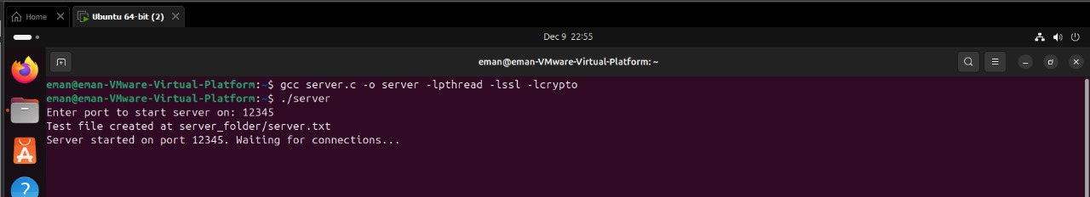
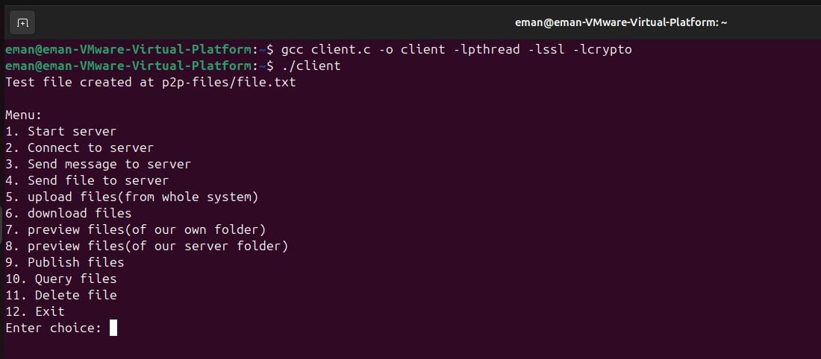
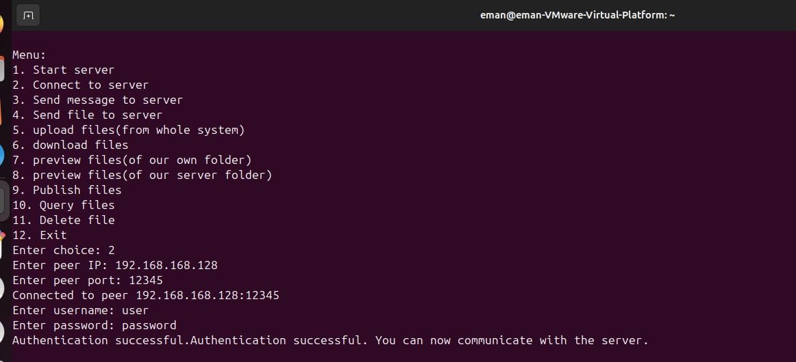

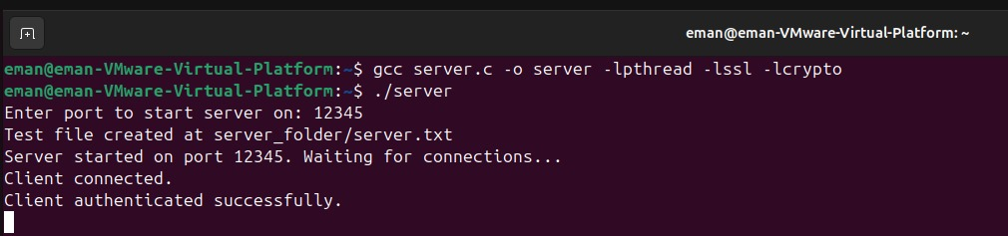

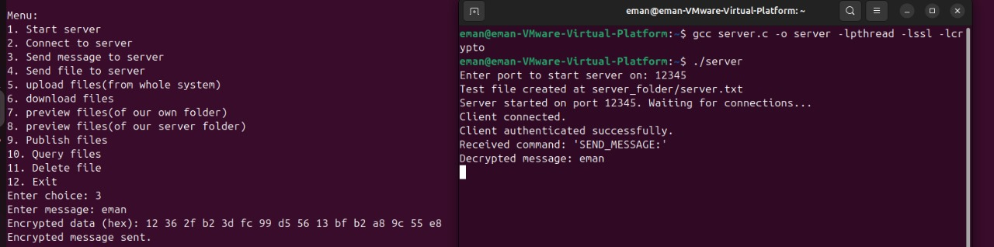

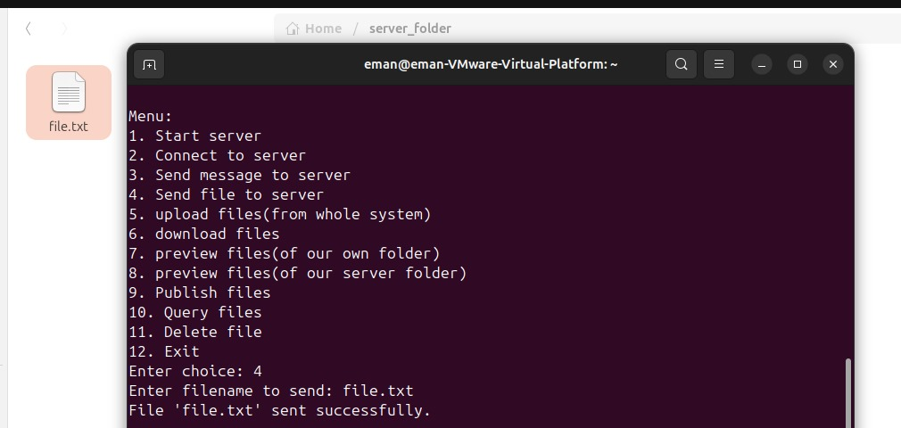

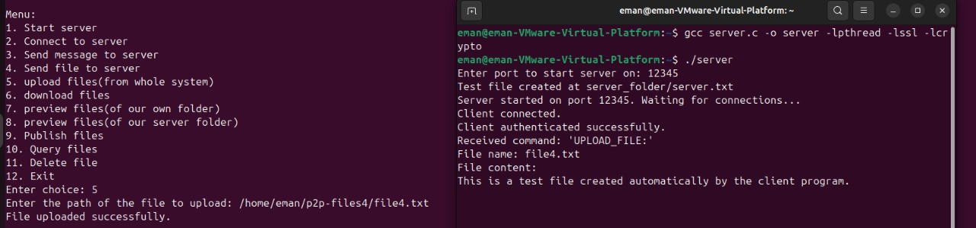

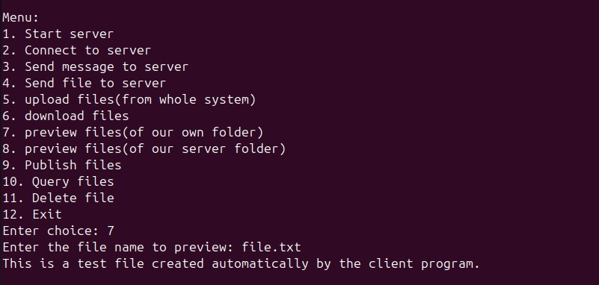

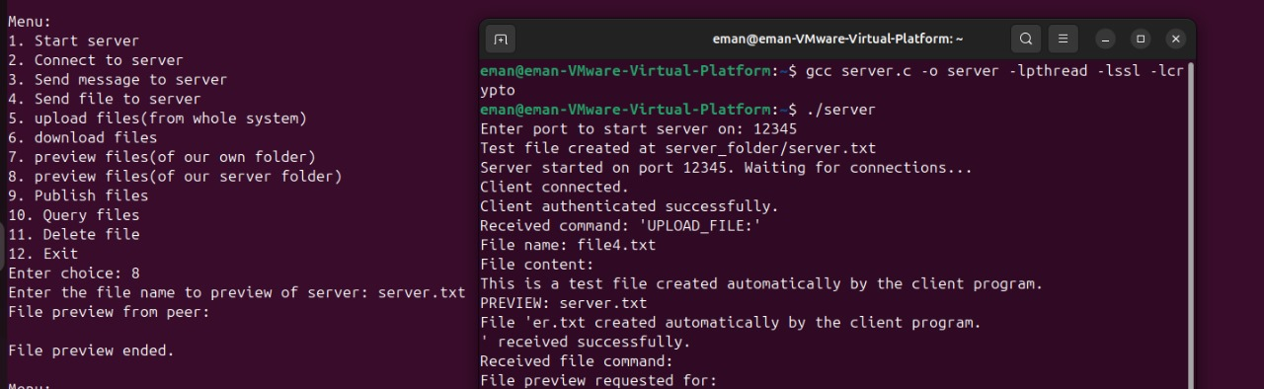

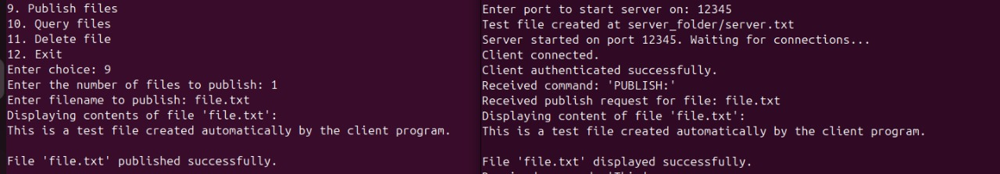

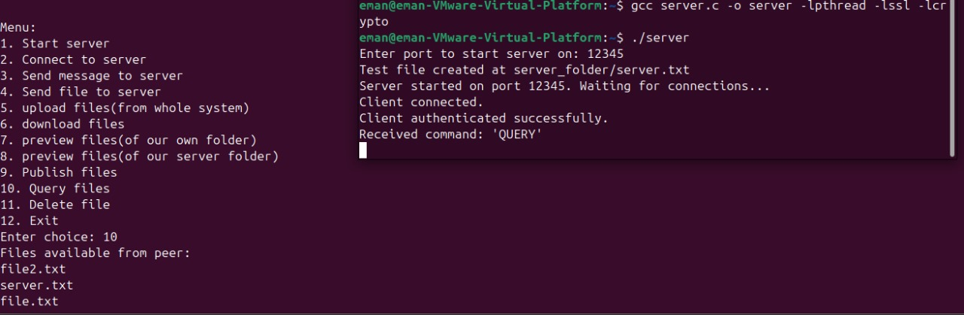

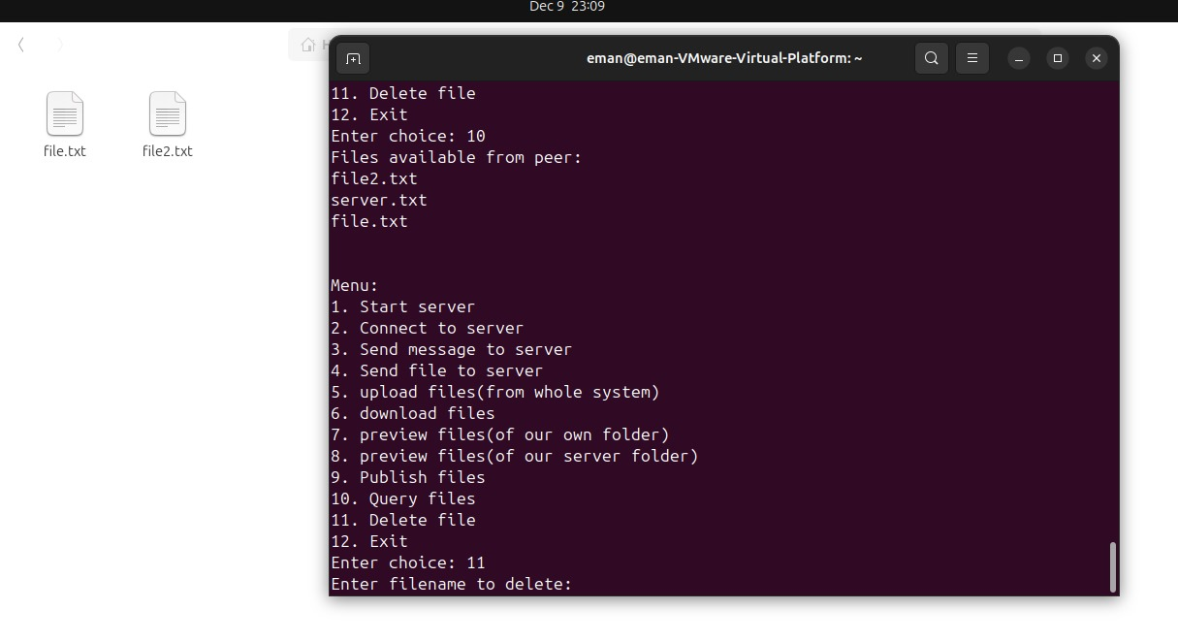

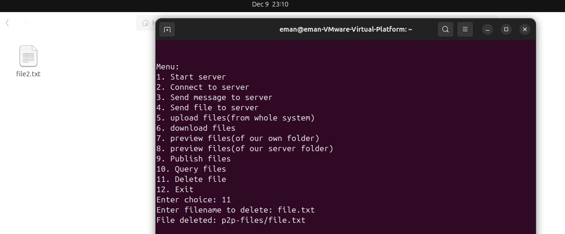

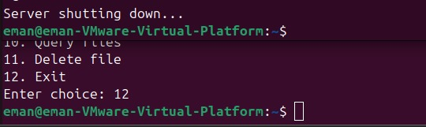
GUI:
